Dharmendrasinhji Arts College, Rajkot
Dr. Yagnik Road, Ph./Fax No. (0281) – 2465632
Govt. Of Gujarat
(Affiliated with Saurashtra University)

7.1.1 Specific Facilities for Women
Specific facilities provided for women in terms of:
a. Safety and security
b. Counselling
c. Common Rooms
Dharmendrasinhji Arts College, Rajkot shows gender sensitivity in providing facilities such as:
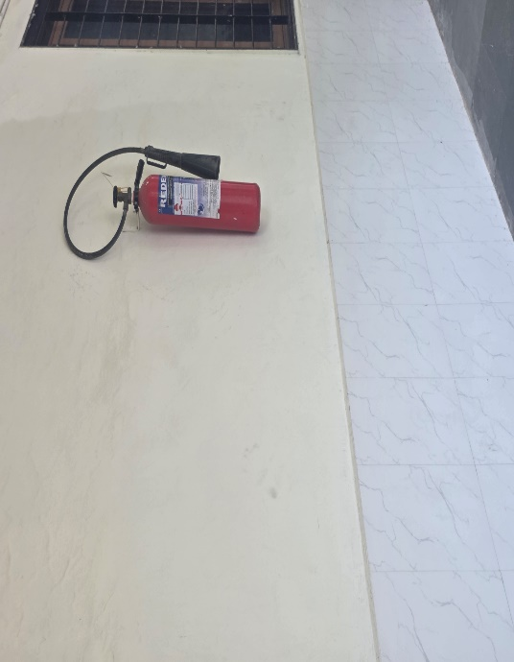
1. Safety and security and Fire Extinguisher
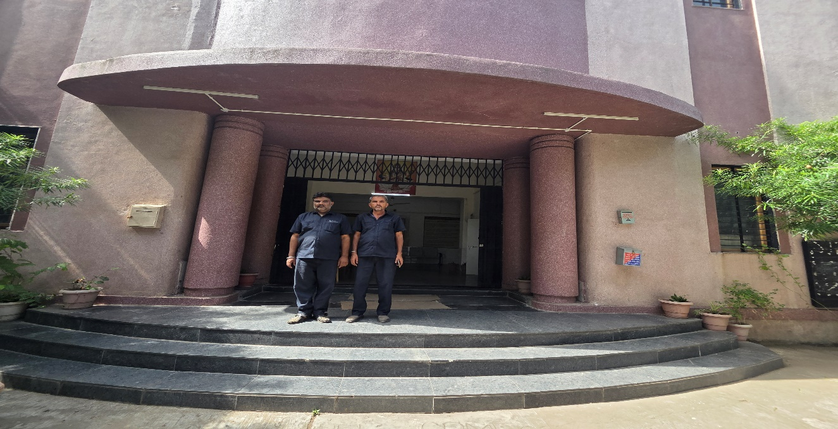
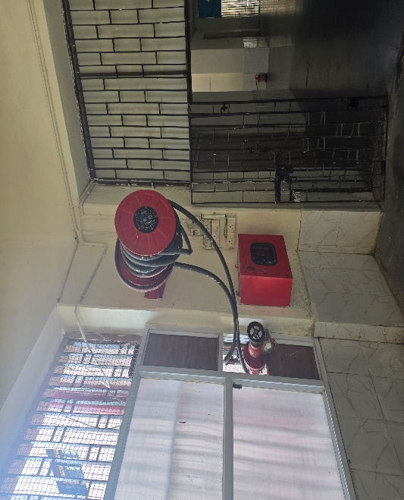
Safety norms are strictly followed by Dharmendrasinhji Arts College, Rajkot.
Security Personnel at the entrance of the college
Safety and security of girls is monitored on the corridors of both the floors of the building, classrooms, playground and library. There are 3 security personnel who safeguard the entire campus. Girl students and all the other females are highly secured under the existing security system.
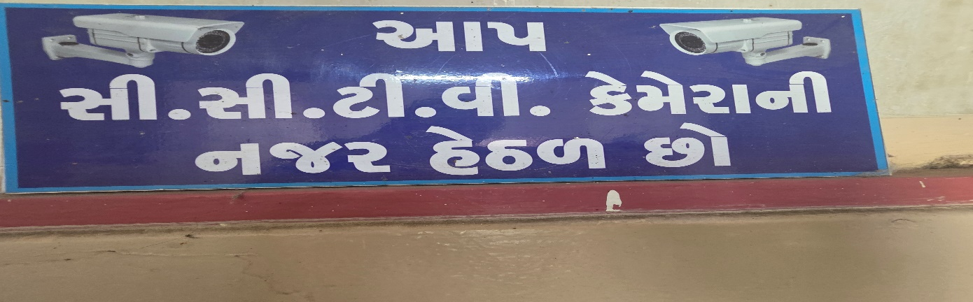
CCTV for Safety & Security
2. Counselling:
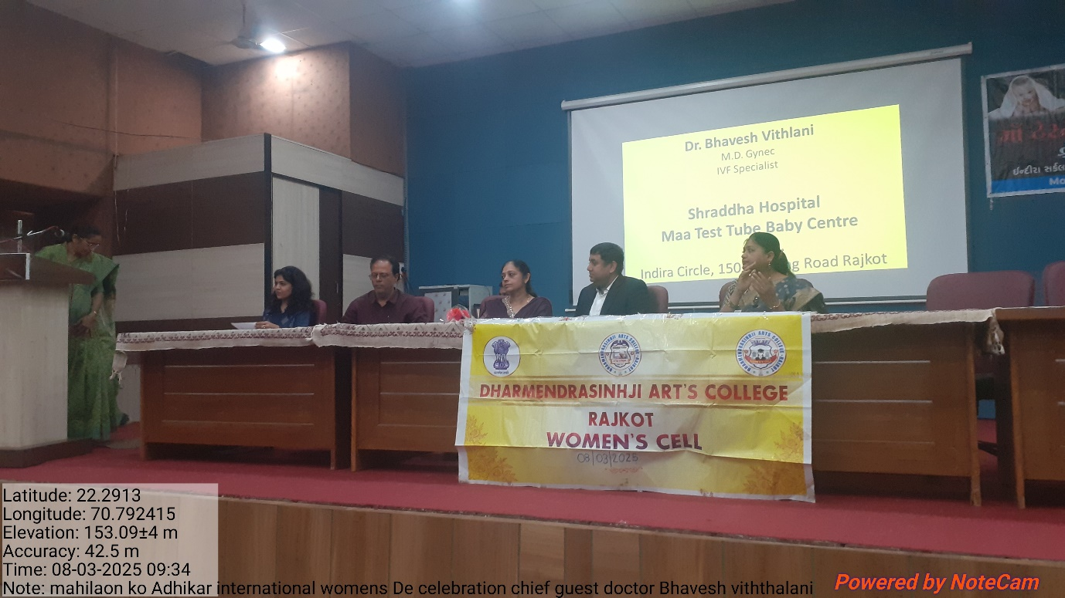
Our college has formed The Grievance Redressal and Appraisal Committee to ensure a fair, impartial and consistent way for redressal of various issues faced in the college.

Counselling of Girl Students
Our college has implemented a Mentor System. The prime objective to implement a Mentor System is to keep the effective mentoring and welfare of the students; a group (main subject) much more 150 students are attached to a faculty member preferably who engages the particular class. This method improves the bond between students and mentors. Special focus is paid to slow learners identified through counselling.
Career Counselling Talks are also organised every year in college for undergraduates’ further progress.

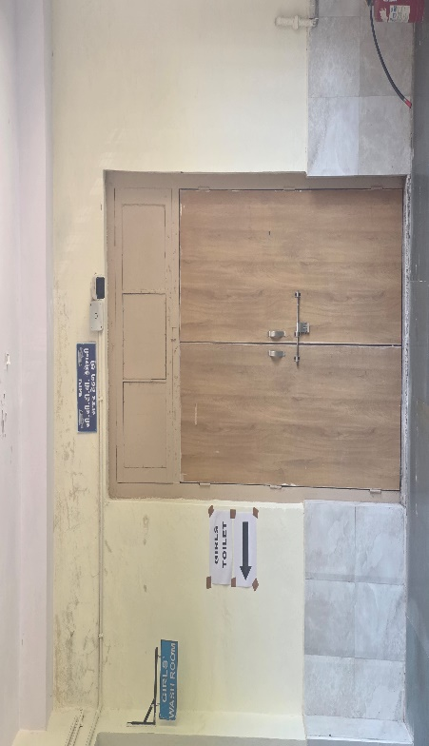
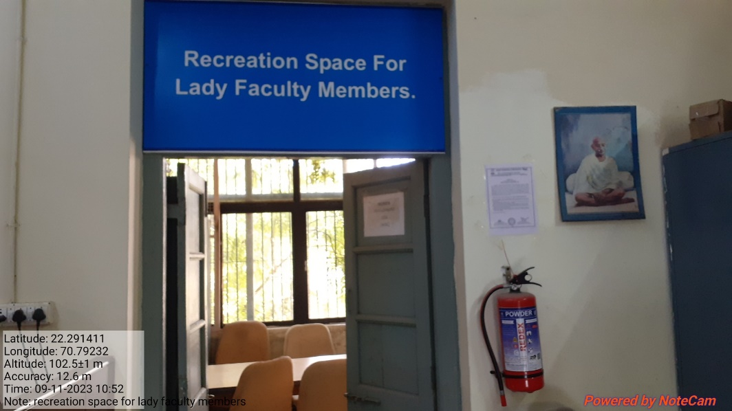
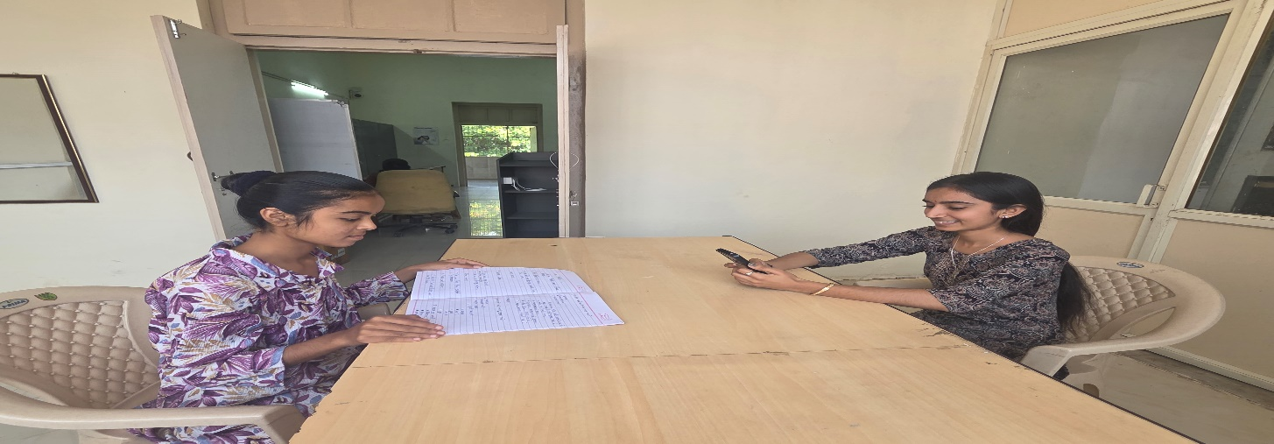
3. Recreational Room for Female Faculty Members:

Separate Common room is provided for girls. A Girls’ Room is provided with necessary facilities like first aid box, rest room, cots, mirror, chair, table, washroom, washbasin, dustbin etc.

